**MIS 273 – Lab 4**

In this lab you’ll install and enable data deduplication on your Windows Server Domain Controller.

**Task 1:** Open up the Lesson 05 PowerPoint slides on implementing data deduplication found under week 3 in Canvas.

Review the fundamentals of data deduplication by reading about it in chapter 5 of the textbook or by going through the first 10 slides for Lesson 05.

Do the steps starting in slide 11 through slide 14. For the data deduplication install use one of the volumes you created in Lab 2 or review lab 2 to remind yourself how to create a new virtual disk and volume to use. Once you have completed these steps from the list of Volumes in File and Storage Services, right-click on the volume that you set up for data deduplication and choose Configure Data Deduplication. Paste a screen-shot of the resulting Deduplication Settings dialog box below.

Paste the screen-shot here:

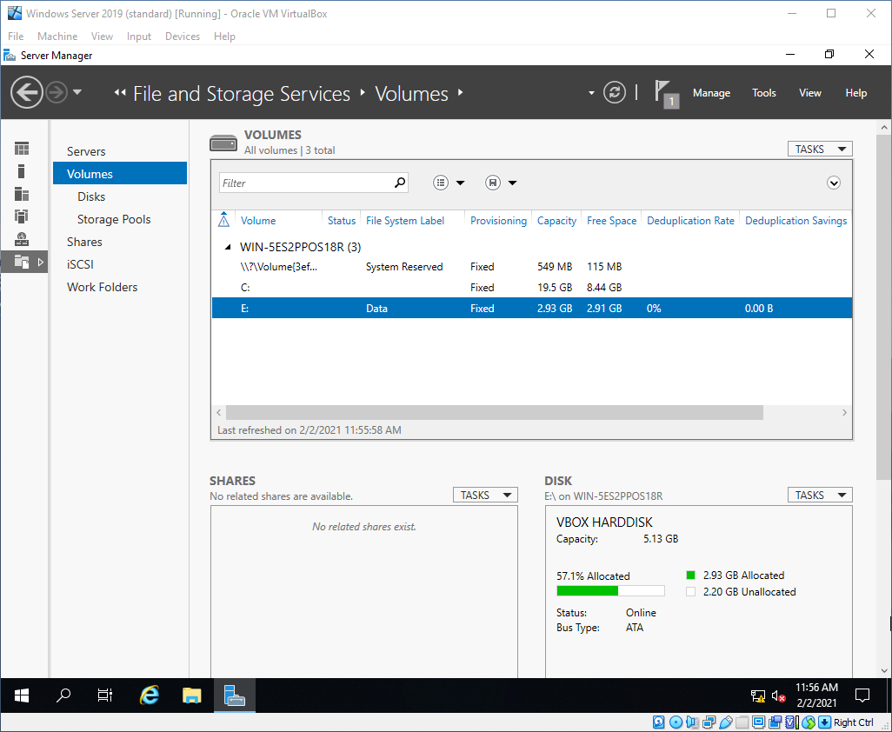

**Task 2:** Read slides 15 through 17. Using PowerShell execute the 3 following commands and paste screen shots of their results below.

Get-DedupStatus

Get-DedupVolume

Get-DedupMetadata

Paste the screen-shots here:

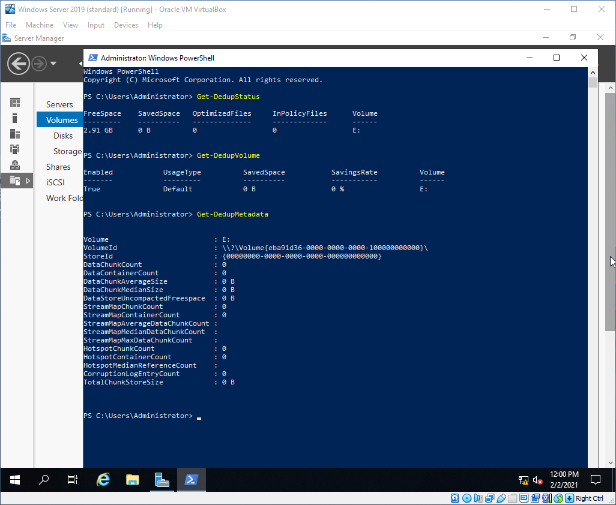

When finished upload this document with the screen-shots to Canvas.